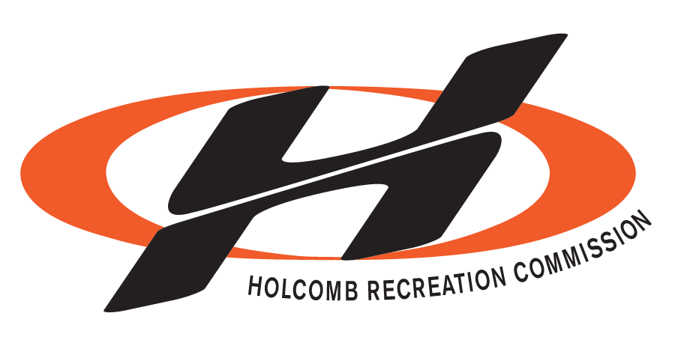

106 WILEY ST.

BOX 78

HOLCOMB, KS. 67851

(620) 277-2152

FAX# (620) 277-2420

Holcomb Recreation Commission
Community Rental Agreement
The Holcomb Recreation Commission buildings and properties are community buildings, and as such, community use of the facilities is encouraged. To insure that the buildings and facilities are used properly, the Holcomb Recreation Commission (Hereinafter referred to as HRC) herby adopt the following terms:

- The buildings are available to any organization, individual, civic or church group and will be rented to any organization, individual, civic or church group. (Hereinafter referred to as Renter)
- The renter signing this agreement must be over 18 years of age and must assume responsibility of the facilities and supervision of minors and all guests on the premises. The renter signing this agreement will be required to present a valid state picture ID and allow us to copy ID used. The copy of ID is used to verify renter to law enforcement if necessary. The renter is totally responsible for all guests on HRC premises and their actions.
- Deposits, CASH ONLY, are required at the time of booking. Rental agreement and deposit must be filled out and paid before renter date is guaranteed. If the renter cancels/reschedule 20 business days in advance the renter will get their deposit back. After 20 business days the renter will forfeit the non-alcohol portion of their deposit paid. Deposit will be refunded within (10) business days, if the building and premises are left in satisfactory condition according to the HRC agreement. (Office Hours are 8:30 a.m. to 5:30 p.m.) (Business days are Monday thru Thursday, excluding holidays) If HRC has to cancel for reasons out of our control, the renter will receive full reimbursement of their deposit.
- No rental fee will be charged for use of the facilities by non-profit, benevolent, governmental, educational, or charitable organizations. Political parties shall be deemed exempt from rental fees unless the building is to be used for a fund-raising activity. However, a clean-up and damage deposit will be required. No exceptions.
- The building may be used at the discretion of the renter subject to all state, county, and local laws and ordinances, and in accordance to deposit and rental agreement. No alcohol will be allowed in the building until alcohol deposit and rent have been paid. All functions may be subject to Finney County Sheriff or City of Holcomb Law Officers supervision or inspection.
- ALCOHOLIC BEVERAGES: NO alcoholic beverages sold on premises. NO alcohol consumption by underage persons at any time. No alcoholic beverages on premises without an alcohol deposit. No alcohol will be allowed outside the building. (Refer to Number 5. Above)
- The Holcomb Recreation buildings and premises are SMOKE-FREE. That means NO smoking anywhere in or outside our property. (Example: parking lot, parks, ball fields, building, etc…)
- If there is proof of alcohol or smoking on HRC premises your deposit will automatically be lost. (Exception to alcohol is the renter has paid the alcohol deposit. This does not include breaking rules on alcohol outside of building, lack of cleaning or damage.)
- Do not use anything that can cause damage to floor or walls. (This includes nails, tape, tacks, paint, jump houses, etc.) No painting or craft activities unless approved, first. (Craft tables are available.) No sports activities such as basketball, soccer, football, skate boarding, bikes, scooters, etc. allowed inside the HRC Community Center. Do not put grease or any other debris down the drain. No objects are to be moved into the building that can in any way cause damage to the flooring or features of the facility. No objects or decorations can touch the lighting on HRC premises.
- The Wellness Center is off limits to all renters and guests. (Do not use the Wellness Entrance)
- All activities will cease at 1:00 a.m. with the exception of private lock-ins pre-approved by HRC Director. (If not out by 2:00 a. m. damage deposit will not be refunded). The building will be cleaned by the renter following the event unless prior arrangements have been made. Renter must set up any tables and/or chairs to be used as well as return them cleaned to storage area. All premises, including building and grounds (including parking lots), must be cleaned and trash deposited in the trash dumpsters. As well, floors must be swept, all spills, must be cleaned and/mopped, and trash deposited in the trash dumpsters located outside the building. See cleaning checklist for more information. Failure to follow clean-up procedures may result in loss of damage deposit.
- The building will be inspected by HRC staff after each use. All damages found at that time will be reported to the Director. All damages to the building contents or premises must be reimbursed by renter over and above the cost of rental and deposit, subject to director approval.
(Labor cost: $50 per hour)
- Any violation of this agreement may forfeit entire deposit.
- The Holcomb Recreation Commission Board and director is authorized to deny permission to any individual or group who has previously violated this rental agreement, pool rules, or have caused damage to any of our property or patrons visiting our premises.

Word: office/Holcomb Recreation Commission Rental Agreement
CLEANING CHECKLIST
______ Pick up all trash on the HRC grounds (includes parking lots) and in the building
______ Sweep floors, dust mop is in storage area with tables and chairs
______ Wipe up all spills. Wet mop and bucket are located in the closet west of the kitchen door. (When mopping please remember to change water when dirty and rinse mop head before starting a new area.)
______ Clean (even when tablecloths are used) and put away all tables and chairs. Remove all tape on tables. (Storage area west of the mop bucket closet) Tables and chairs must be put away clean and as show in the picture on the wall. (If staff has to arrange tables or chairs there will be a charge against deposit.)
______ Dump all trash. (New trash bags in all trash cans) Trash bags are supplied by HRC. Dumpster is located on the east side of the building. (Trash bags are in the kitchen drawer below the telephone.)
______ Wash and put away all dishes, roasters, Gott containers, coffee maker, utensils, etc. used.
______ Clean stove, oven, microwave oven, and counter tops. (Mop kitchen floor)
______ Take all food when you leave, HRC staff will throw away all leftovers.
______ Vacuum or mop all lobby areas. Vacuum is located in the closet outside of the women’s restroom.
______ Pick up all trash in restrooms, including around toilets. Flush and clean all toilets and urinals. Empty restroom trash cans and the women’s trash cans in stalls. (Trash bags are in the closet by women’s restroom or in the kitchen.) Clean mirrors, countertops, toilets and mop bathroom floors.
______ Turn off all lights.
______ Double check all doors to make sure they are locked.
______ Please leave dirty towels in the in the front closet laundry basket.
** If any of these rules are not followed or cleaning tasks not complete, the HRC has the right to withhold all or part of your deposit. It is your responsibility to leave the facility as you found it! (Cleaning fee is $50 per hour) (If you rent the backroom and your guest(s) are in the office front area you will be charge $75) If you are put on our watch list the next time you rent you will pay $200 cash extra deposit.
** Any damage must be reported to HRC staff before the start of your event. You must check for damage and notify HRC staff before your event begins if you do not want to be held responsible. You are responsible for all damage after your event has begun.
Emergency Contacts
Eric Jantz 620-290-3204 Griffin Brunson 620-805-2529 Mike Stegman 620-290-3842

Holcomb Recreation Commission Rental and Deposit Fees
Holcomb/USD 363 Resident - Residents living in Holcomb USD 363 School District
(Proof of residence may be required)

Board Meeting Room (Capacity 26) _____ $50 (Cash)
Deposit _____ $50 Cash

Backroom/Kitchen (Capacity 200) _____ $250 (Cash)
Deposit _____ $250 Cash or ($500 Cash with alcohol allowed inside building only)

Set Fee Prior Day – (decorated only after 3:00 p.m. if room is not rented) $100 (Full weekend price is $475.00 includes Sunday to 6:00 pm if you need more time need to paid full price, same for Friday.)

The undersigned Renter agrees to pay the above rent and deposit. (If renting for another party you are responsible for all damage and cleanup procedures. Also, if rules are not followed you could lose your right to rent from HRC in the future.)

Non-Resident of Holcomb/USD 363 Board Meeting Room (Capacity 26) _____ $75 (Cash) Deposit _____ $100 Cash
Backroom/Kitchen (Capacity 200) _____ $450 (Cash)
Deposit _____ $450 Cash or ($650 cash with alcohol allowed inside building only)
Set Fee Prior Day – (decorated only after 3:00 p.m. if room is not rented) $200 (Full weekend price is $875.00 includes Sunday to 6:00 pm if you need more time need to paid full price, same for Friday.)
The undersigned Renter agrees to pay the above rent and deposit.

Release of Liability
The undersigned Renter does hereby agree to assume full responsibility during the time of the Holcomb Recreation Commission Building and premises is rented from the Holcomb Recreation Commission and further agrees to hold the Holcomb Recreation Commission, its’ agents, and its’ officials harmless from any type of liability, including personal injury or property damage of any kind caused during the lease period.

Renter further agrees to repair or replace, to the satisfaction of the Holcomb Recreation Commission Board any property damage during the rental of the building, including the surrounding premises.

Renter is also aware of the rental agreement terms contained herein and agrees to abide by such terms.
Security cameras are located throughout the HRC facility.

Dated and signed this _______ day of ________________, 20______

By signing below you acknowledge this agreement and have received a copy of the agreement and all information provided by you is correct.
____________________________________________ _________________________________________________ Renter Signature Print Renter Name

Mailing & Street Address: _______________________________________________________________________________________

Phone: _________________________________ E-Mail Address: ___________________________________________________

Building Rental Date: ______________________ Start and End Time: ________________________________________________

Type of Activity: __________________________ Will food be served? ________________ Estimate number of guest _________

Date Deposit Returned: ____________________ Signature of Renter receiving deposit: _________________________________

